Praying the Stations of the Cross With Your Children
If you want to introduce your kids to the very heart of the Christian story, praying the Stations of the Cross
(or Way of the Cross) with them is an excellent way to start.
It is a wonderful way to introduce them to the story of Jesus’ Passion (his suffering and death), breaking it down into discrete pieces that kids can more easily memorize. But the Stations are more than the re-telling of a story: it is a prayerful participation in the event that lies at the heart of Christianity. At its best, the Stations engage kids at a spiritual level.
Praying the Stations of the Cross at home offers flexibility and convenience for families with young children. If you go this route, try to round up an illustrated guide or artworks to represent the stations. You can either present each artwork on your prayer table as you pray that Station, or you can post the artworks around your home to make your very own Way of the Cross.
Below is a 25 Stations of the Cross video geared for grades 1- 6 which explains each station and how children can relate to them while praying along with the children. Just control click on the Way of the Cross for Kids link in the box below.
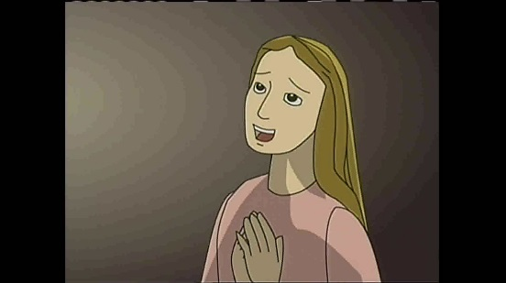 | Way of the Cross for Kids  Christine, Eva, Joseph and Enrique follow the 14 Stations of the Passion and Death of Our Lord Jesus Christ.  youtu.be
Below is a link to Loyola Press’ Multimedia Stations of the Cross. You can print out the story and read it as a family or watch the online slideshow presentation together.
https://www.loyolapress.com/our-catholic-faith/liturgical-year/lent/stations-of-the-cross/multimedia-stations-of-the-cross-for-children
The next 25 minute video is geared for older children (grades 7 and up) and depicts each colorful station of the cross with the explanation of it by Father Reed.
https://youtu.be/tLGwLMLcq8k.
A Catholic Moment - Take Up Your Cross by Joseph Lacombe
Denying ourselves, sacrificing ourselves for the sake of others, bearing our daily crosses, and offering all of that up to God for the merits of others.
This is a blessing, a grace of the crosses that come our way. Just as with Jesus, He announces to the disciples that He must go to Jerusalem and suffer greatly, and be killed. He must do this for the world. He must bear His literal cross, and be crucified, and die for us, so that the ship can be righted, so to speak. Peter gets so upset at this and tells Jesus that this will never happen! But Peter didn’t listen to the rest of Jesus’ words – that on the third day, He would be raised.
There was a reason and a purpose for all that Jesus was to do and undergo, and there was a joy and a gift – a joy of salvation and a gift of eternal life.
And so, in our daily crosses, we too can find joy. We too can receive gifts and graces. God doesn’t send the suffering and tragedy our way, saying “Ha! let’s see how Joe deals with this!” I know many people think that, asking why would
a good God let suffering happen. Why a good God would let such tragedy and wrongs happen to innocent people? Why would God send a hurricane to Texas and let it dump 50 inches of rain in an area with millions of people and watch their lives be destroyed by flooding? And that’s just here in the United States. This is happening in other parts of the world too. Why would a good God do this, we ask…?
God doesn’t do this. It is a fallen world, people have free will. We live in a world where there is nature and science, disease and weather – things just simply happen. Hurricanes hit. People get into car accidents. Planes crash. People get cancer. People get depressed. These things just happen, for no apparent reason. People get persecuted for their faith, for trying to stand-up to the negative and do something good.
I’ve experienced these or know people directly impacted by every one of these occurrences. Every time, I have questioned – why? I never get an answer as to why. I know that God does not send these things our way, but I do know that He uses them for the better when they do occur, as opportunities for us to reach out to Him, to rely and trust in Him, to let Him guide us, and to grow our faith. To pull us towards Him.
I do know that our crosses in life, can purify us, shape our soul, our character, and our strength – if we trust in and rely on God to get us through, even if we don’t understand.
And I do know, that if we deny ourselves, sacrifice our own will and our selfish desires for the will of God, and offer up our sacrifices and suffering to Him for the good of someone else, that there is merit here. Not only does this purify our own soul, but I’ve seen prayers answered – for others – in this very act.
And so as much as I hate to see and experience any kind of trial and suffering or tragedy, there is joy and grace and a gift to be found there if we use these as an opportunity to love. To love and lean on Christ, and use these as an opportunity to love others.
If we conform ourselves to the world, to society, and let this overcome us, and we wallow in our own self-pity and selfish desires, we will be destroyed – eternally. But with each cross that comes our way, if we look at it as an opportunity to renew and grow our prayer life, and our spiritual relationship with God, and deny our wills and look to these crosses as a way to help others somehow, and ask God to show us that – we will grow immensely and we, too will be raised after our death and live eternally with Christ.
This is the joy to be found in our daily crosses. But we must deny ourselves. We must deny our will, and discern the will of God. We’ve got to deny our own wants, our own sorrows, our own selfish desires and simply let Him guide us, so that we can follow.
We must not ask the question, why would God Let this happen – but ask what is God wanting me to learn from this experience? What is God wanting me to do – right now – as a result of this cross? What is God wanting me to share with others based upon what I am experiencing? Where is God pulling me closer to Him?
In every single instance, we will be tempted not to do this. We will be tempted to give into our own will and desires, and focus on our self, and turn away from Christ. We will have obstacles come before us, trying to prevent us from thinking this way, and following God. This is when we exclaim, as Jesus did, “Get behind me Satan! You are an obstacle to me.”
Jesus will be there, to show us the way, to renew and deepen our understanding of Him, and lead us to all that is good and pleasing and perfect.
TAKE UP YOUR CROSS PRAYER
Wait on the Lord: be of good courage, and He shall strengthen your heart: Wait on the Lord:
He is our help and our shield. By following Jesus’ footsteps and waiting on Him who is the ultimate healer of our lives, He will provide rest to our souls and make our burdens easy and light.
Of these things I pray in the sacred name of Jesus Christ. Amen.
Please print and hang this crucifix in your house to show that you are a follower of Jesus.
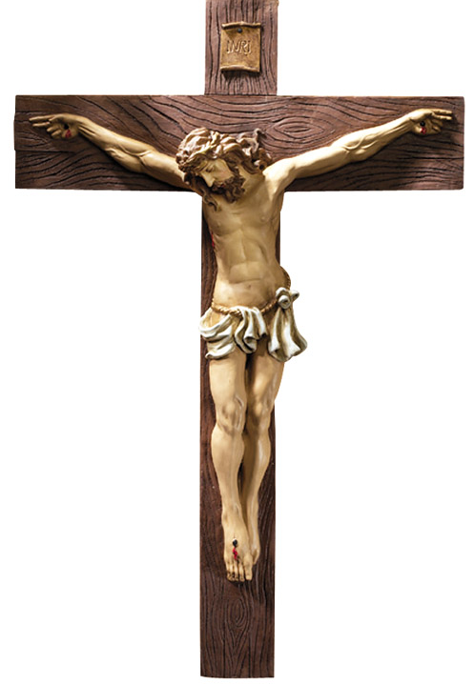

Prayer Reflection / Meditation

Before reflection begins, find a quiet room to sit and dim the lights. You can either put a small lamp or candle in the center of a table. Ask your child(ren) to fold their arms on the table and lay their head on their arms with their eyes closed. Have them take a deep breath in and then breathe out slowly. Explain to them that you are speaking to them in God’s voice and ask them to listen to your words with their hearts and minds open as you slowly read the passage below.

In Hard Times

By his power we live and move and exist. Acts 17:28

Learn to appreciate hard times. I know that’s not easy to do. But as we face troubles and challenges together, your trust in Me will grow.
When you’re facing a tough time, think about these three things: your relationship with Me, My promises in the Bible, and past experiences of making it through hard times. Remember that you and I together can handle anything.
When you think about the other times I helped you, you may be tempted to say, “That was when; things are different now!” But remember who I am! Your situation may have changed, but I never do. I stay the same throughout time and eternity. Take this truth to heart, and let it inspire your confidence in Me. You live in Me. You walk in Me. You are in Me.

